HEALTH REMINDER Design Document
CIS-043-32075 Team 8 Version: v1.1 – April 06, 2026
Date of Submission: Apr 20, 2026
Prepared by: Team 8 Course: CIS-043-32075

1. Introduction
Managing healthcare can be challenging, especially for patients who need to keep track of multiple appointments, doctors, and medications. This application is designed to simplify that process by organizing essential health information.
With this app, patients can monitor appointments, maintain a record of their healthcare providers, and track medications with reminders to ensure timely intake.

2. Functional Requirements
2.1 Account Login Allows users to sign up, register, and log into their accounts.
2.2 Medication Management Enables users to create, maintain, edit and delete medication schedules, including dosage amounts. These schedules are integrated with the calendar and reminder system.
2.3 Calendar and Reminders Displays reminders for today’s appointments and medications. Enables users to create, edit, and delete appointments.
2.4 Doctors Management Allows users to create, maintain, edit and delete detailed information about their healthcare providers.
2.5 Share Information Enables users to send a summary of their health information (appointments, medications, doctors) via email.
2.6 Application Navigation Flow (See Figure 1 – Proposed Use Case Flow Diagram on the following page or as an appendix image.)

3. Non-Functional Requirements
- Security: Passwords will be hashed (never stored in plain text).
- Performance: All screens load in < 30 seconds; reminders fire reliably.
- Usability: Intuitive tabbed interface with keyboard navigation support.
- Reliability: Offline-first desktop application with graceful error handling.
- Platform: Windows via JavaFX.

4. Data Model
Proposed core entities (to be finalized in UML Class Diagram):
- User (id, fullName, email, username, passwordHash)
- Medication (userId, name, dosage, frequency, startDate, endDate, notes)
- Appointment (userId, dateTime, doctorId, notes)
- Doctor (userId, name, specialty, phone, email, address)

5. GUI and UML Design
User Registration & Login
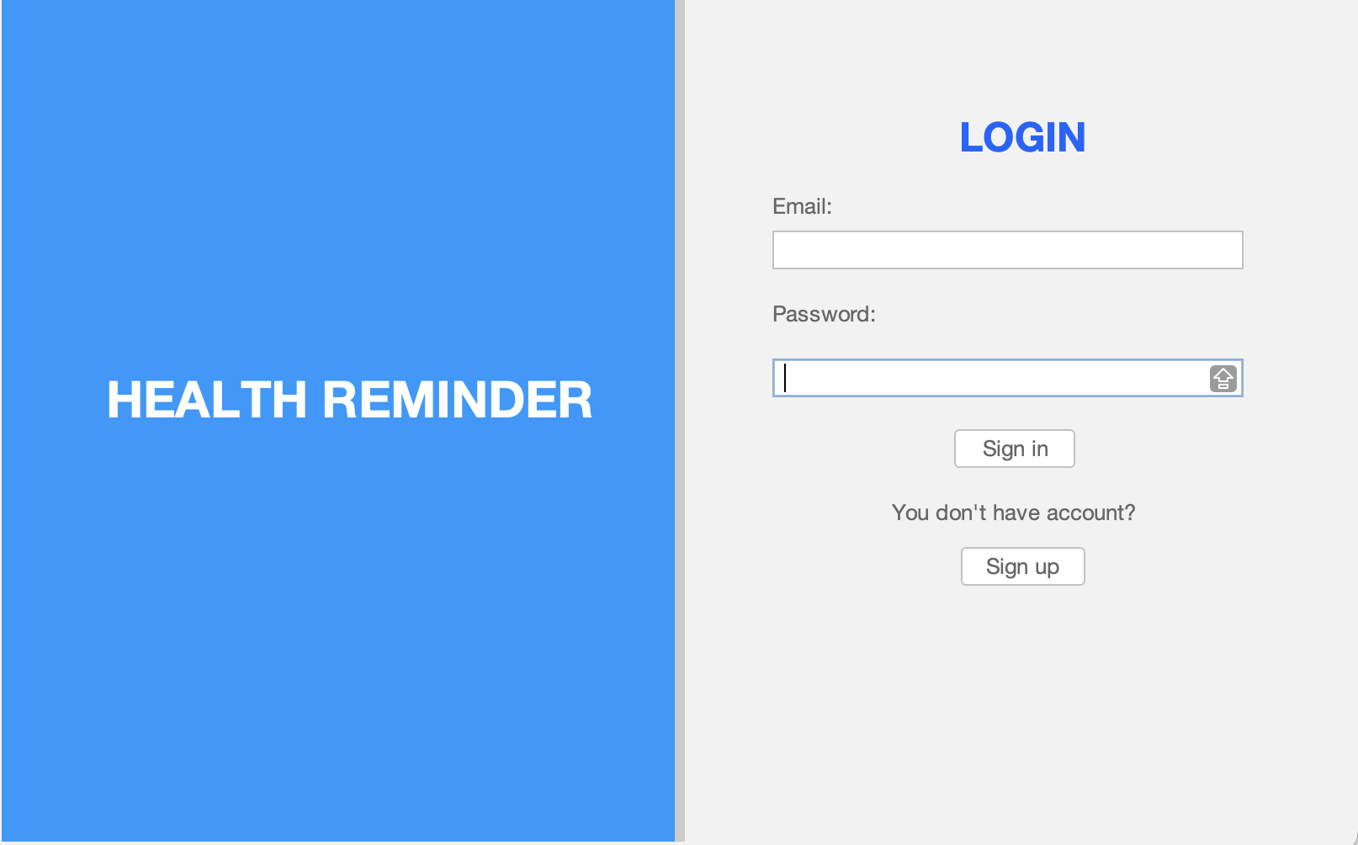
GUI

UML Diagrams
All diagrams are suitable for inclusion in a formal software design document.

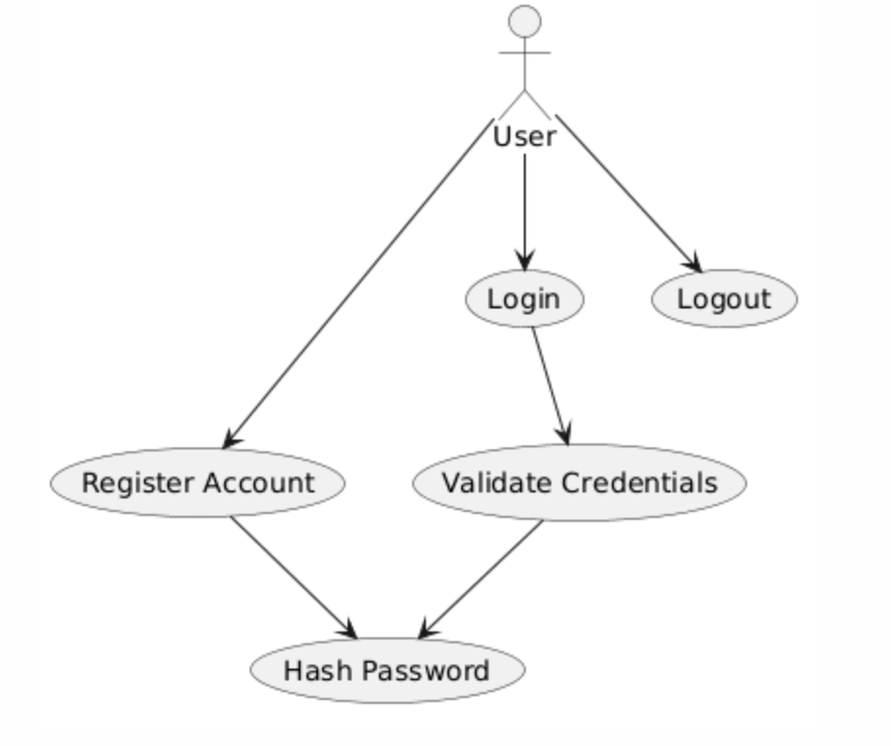
5.1 Use Case Diagram – Registration & Login

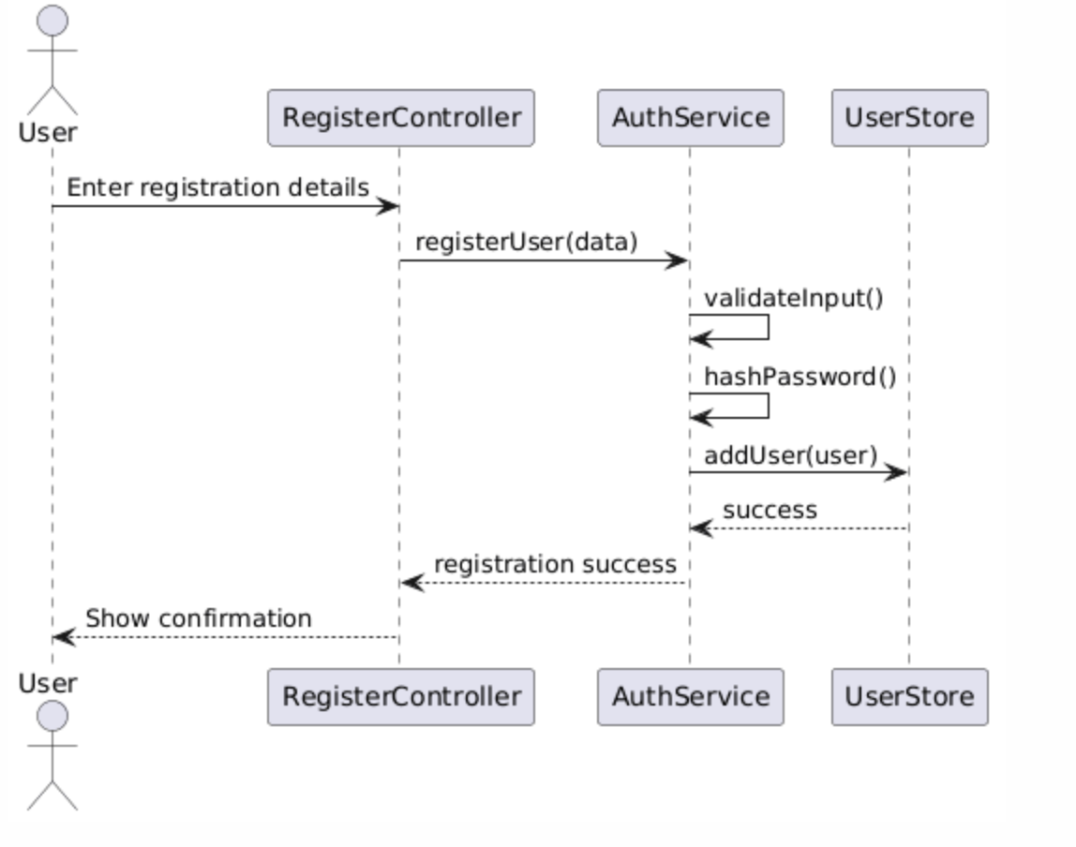
5.2 Sequence Diagram – User Registration (Hardcoded Storage)

5.3 Sequence Diagram – User Login (Hardcoded Storage)
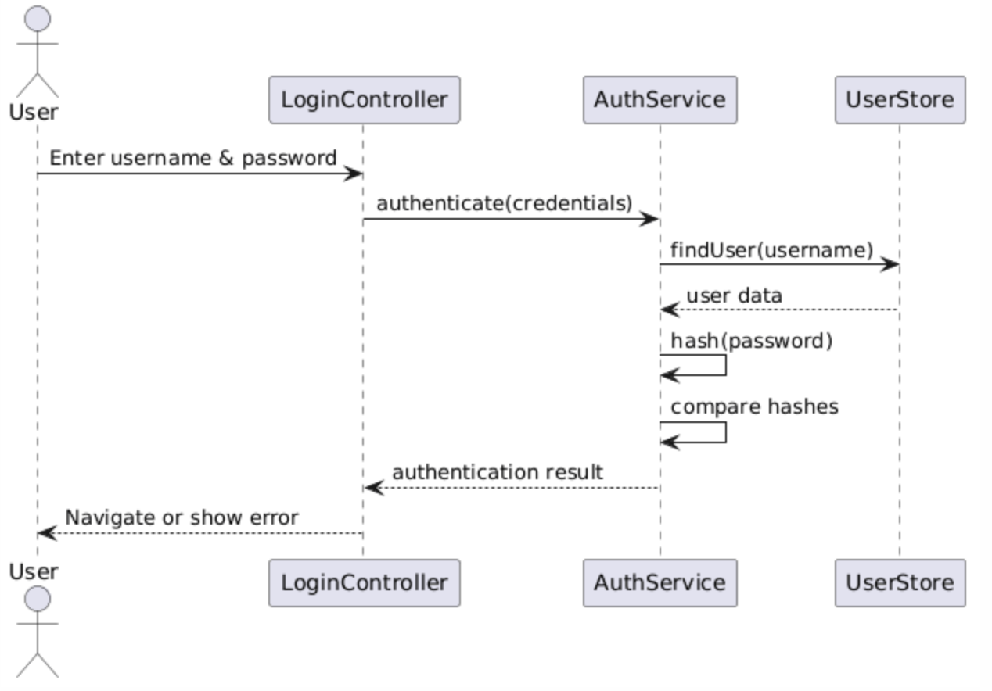

2.4 Class Diagram – Authentication Module (Demo)
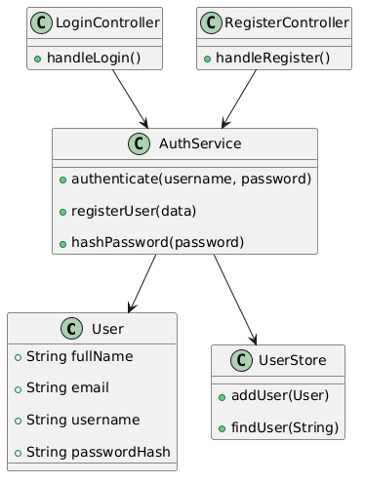

Treatment and Medicine
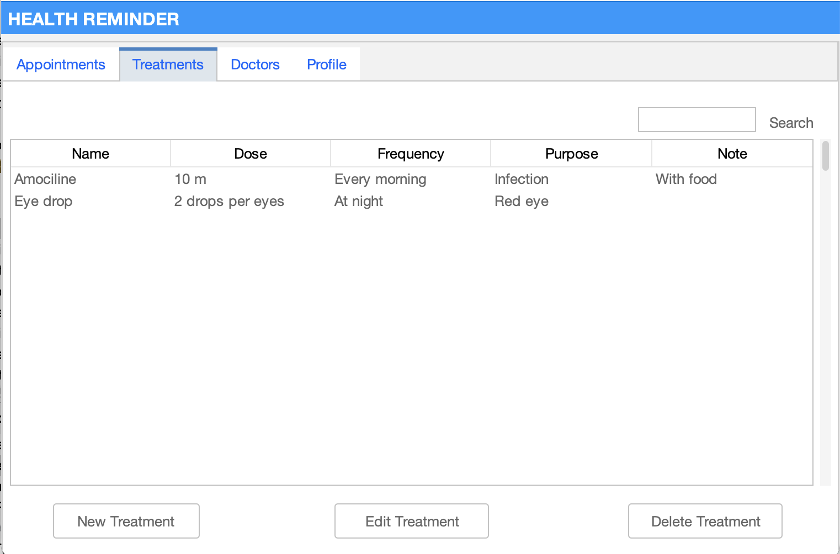
GUI

UML
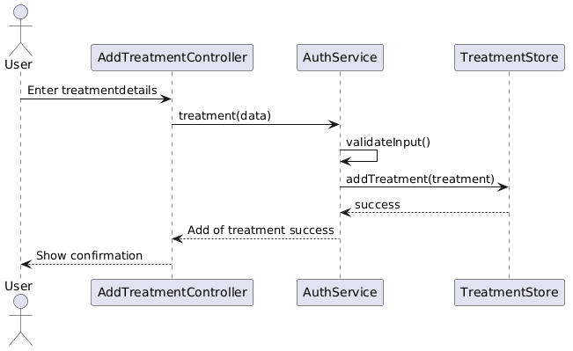
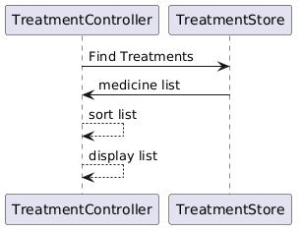
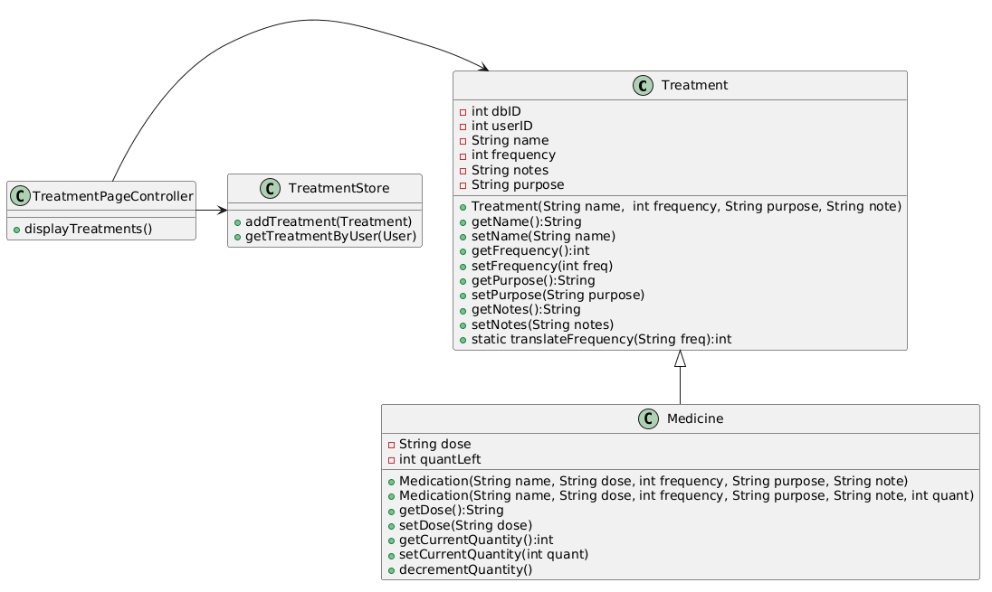

Appointments
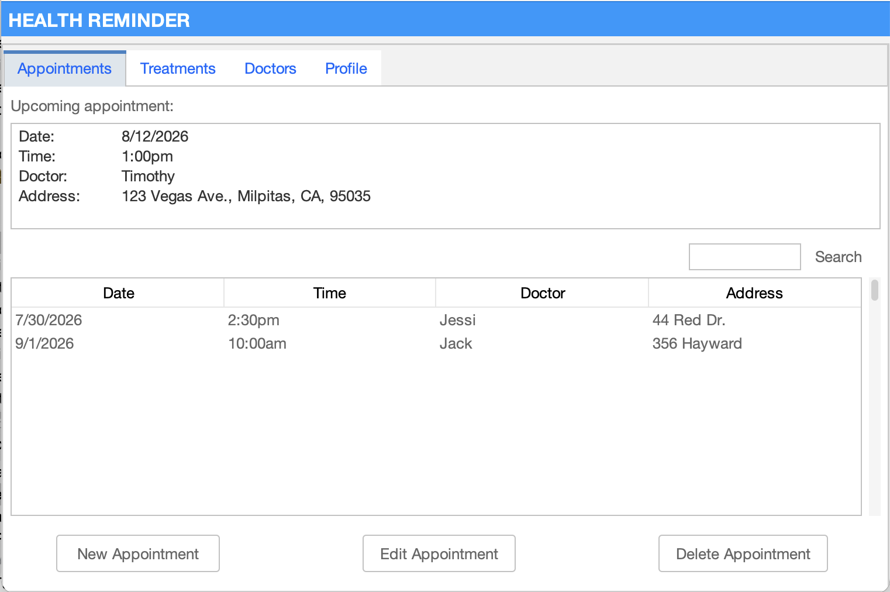
GUI

UML
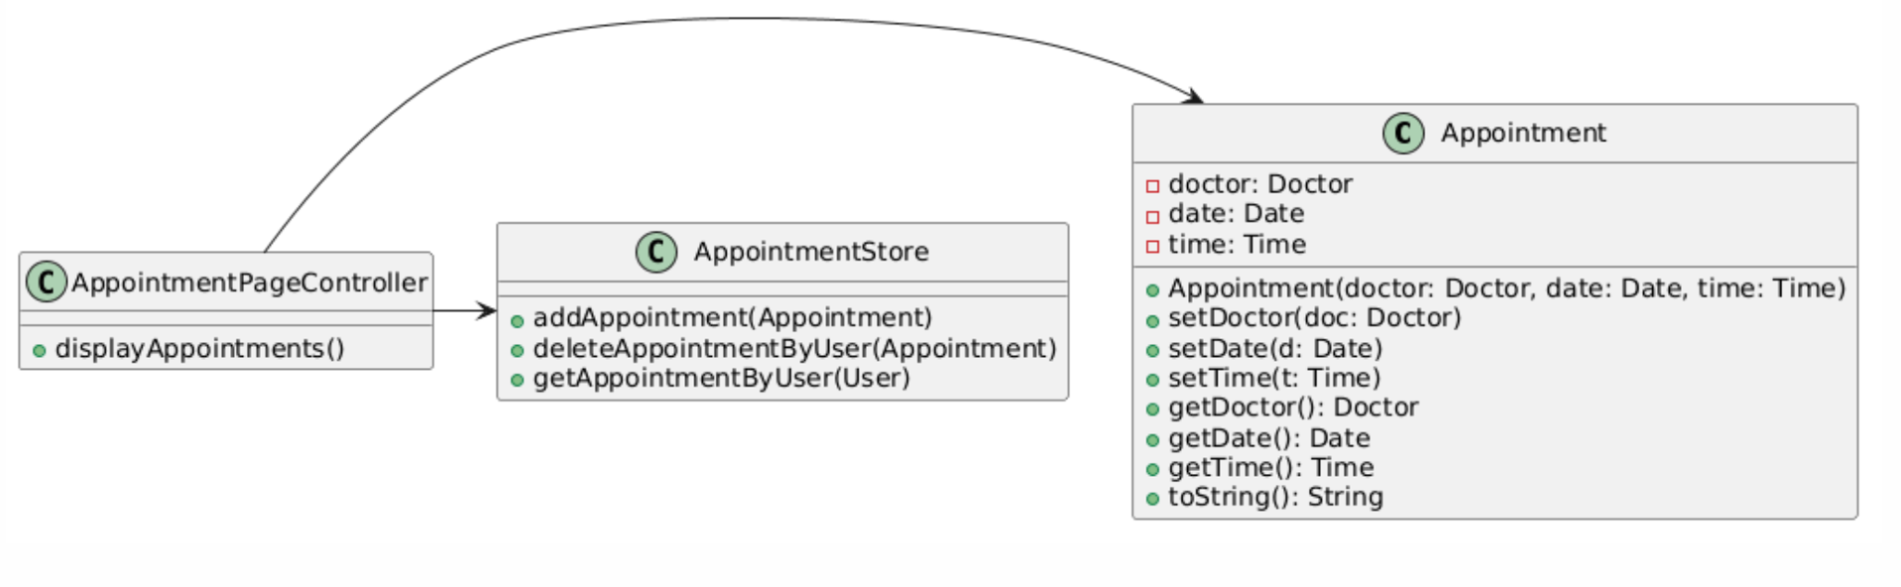
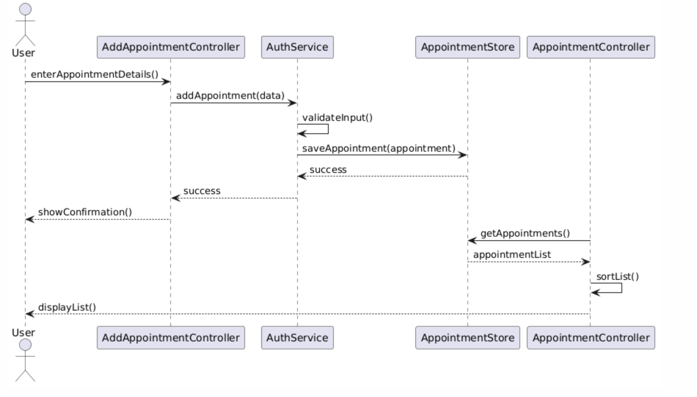
Doctors
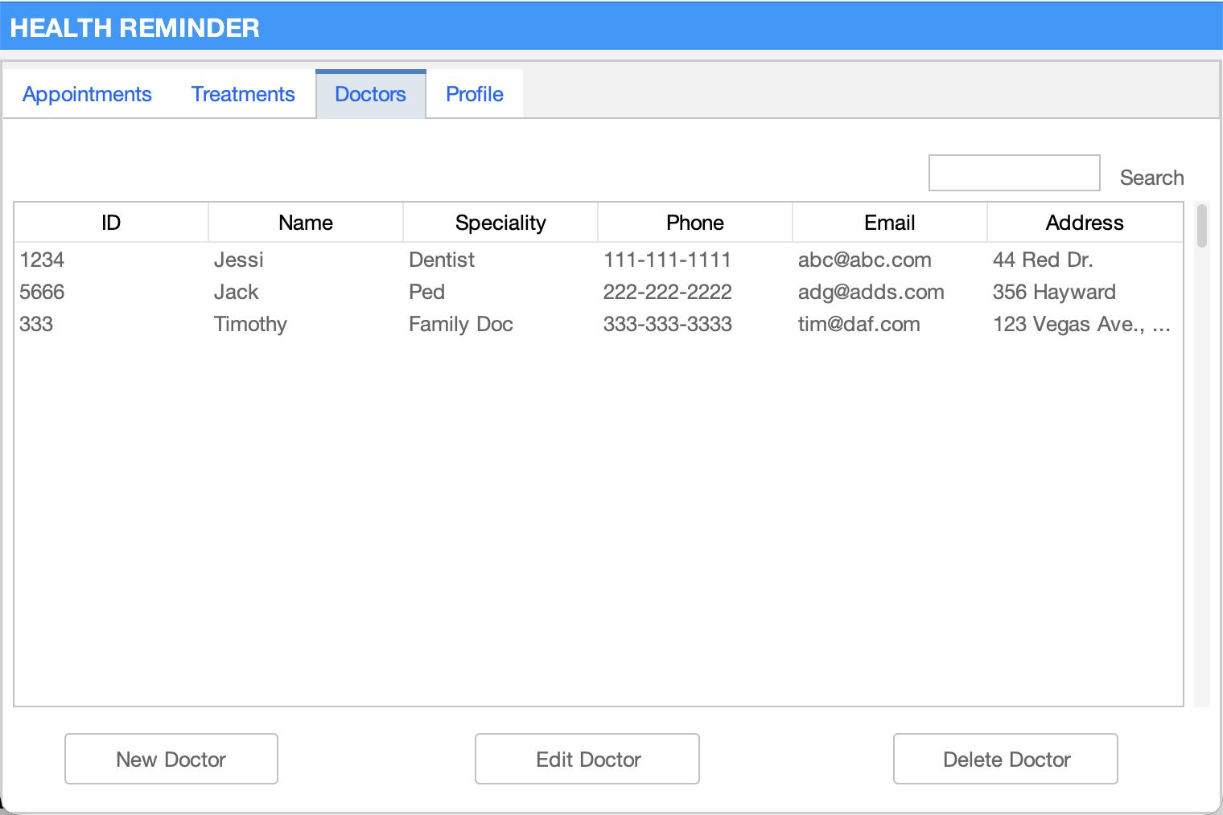
GUI
UML
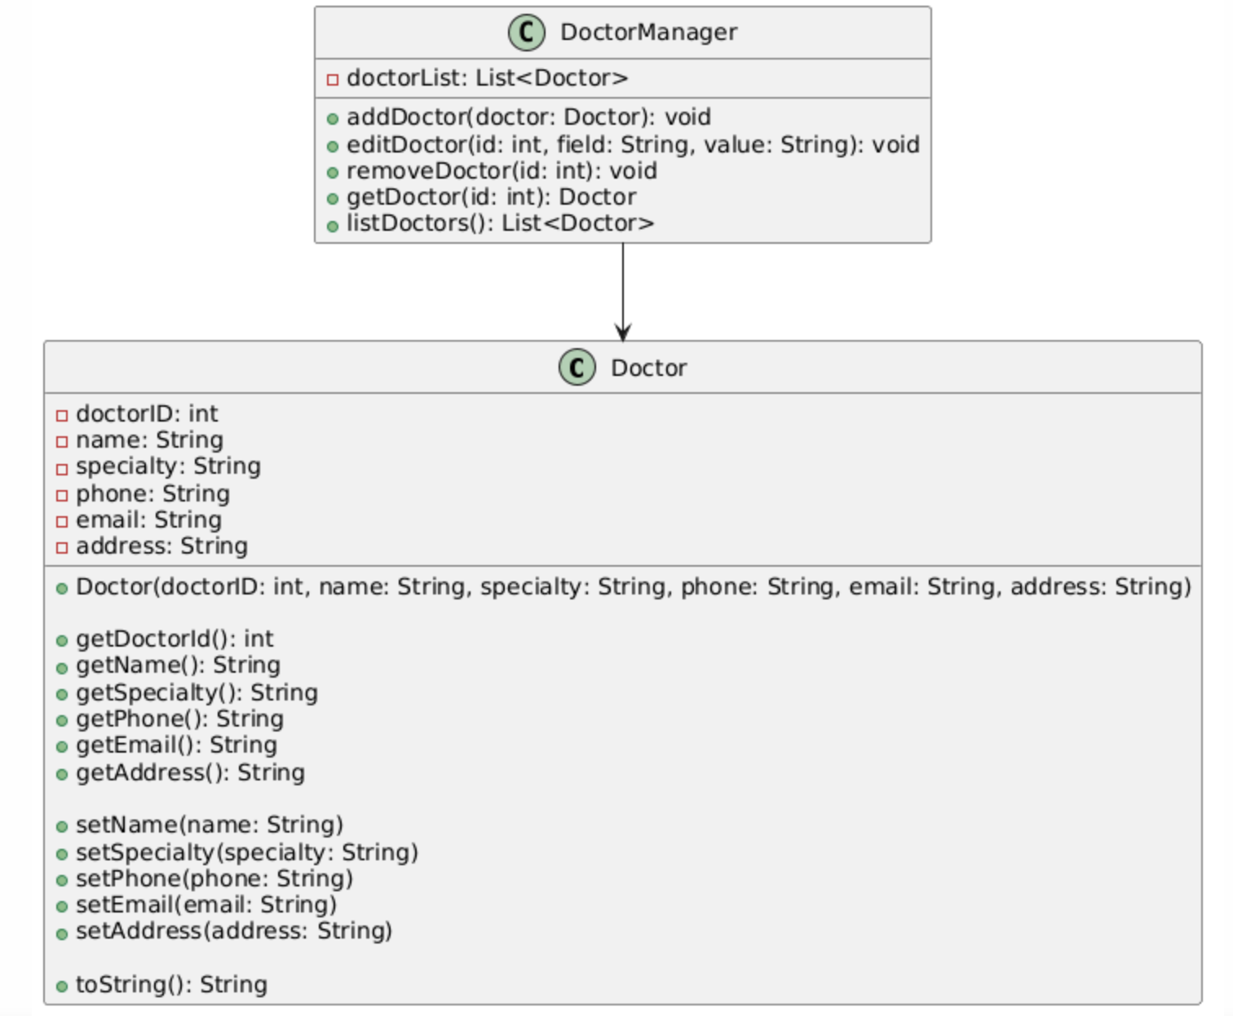

Profile
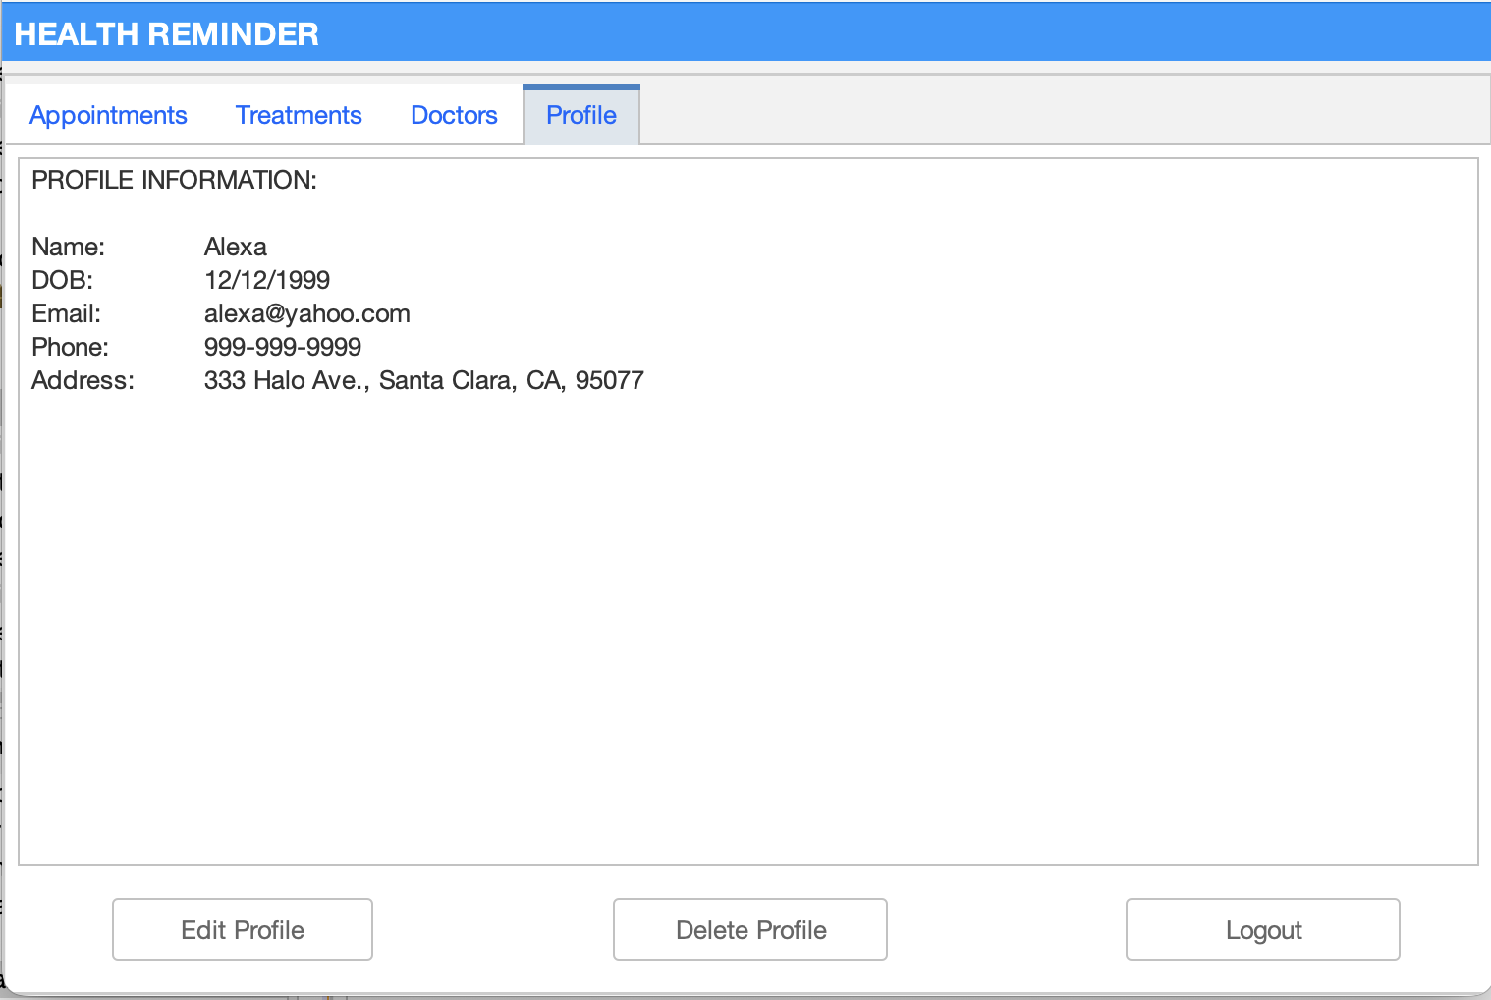
GUI
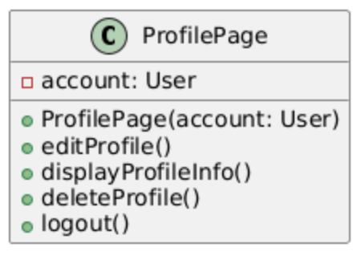
UML

6. Architecture & Tech Stack
- Language: Java 21
- GUI: JavaFX 21 + SceneBuilder (FXML)
- Persistence: SQLite via JDBC (lightweight, no server required)
- Email: JavaMail API
- Build Tool: Maven
- IDE: IntelliJ IDEA (recommended)

7. Scope Boundaries
In Scope
- All functions listed in Section 2
- Hard-coded data
- Basic email sharing via desktop client or JavaMail
Out of Scope
- Cloud synchronization
- Multi-user / family accounts
- Mobile version
- Push notifications
- Advanced reporting / analytics

8. Risks & Assumptions
Risks
- Reminder accuracy on minimized application
- Data privacy (local storage only)
- Email delivery reliability
Assumptions
- Users have a desktop environment with Java 21 installed
- Single-user application
- Internet required only for email feature

9. Deliverables & Timeline
- Week 2: Complete UML diagrams for all modules
- Week 3: GUI prototypes (SceneBuilder FXML)
- Week 5: Core CRUD operations + database integration
- Week 7: Email functionality, testing, and final demo

Appendix A – Team & Responsibilities
Team Members
- Amy Schmieder
- Jincy Jacob
- Trong Khoi Vu
- Leandro Kirchheim Coutinho
- Tam Nguyen
Task Assignment
- Jincy Jacob: UML for login and register
- Amy Schmieder: UML for medication management
- Trong Khoi Vu: UML for Doctor management
- Leandro Kirchheim Coutinho: UML for profile page
- Tam Nguyen: UML for Calendar
Project Progress
- Finalized the project idea
- Discussed and defined the application’s functions and workflow, including the flowchart diagram
- Currently developing UMLs for each function, then will move to implementation and GUI design

Figure 1: Proposed Use Case Flow Diagram
